|  |  |
| --- | --- |
|  | **RV004X CAB**  ESSENTIAL HYGIENE PPE  **DISPOSABLE 3-PLY MEDICAL MASK**  (Pack of 50) |
| **Origin:** China  2842020 | **Commodity Code:** 6307909810 |
| **Size : One Size** | **Tech:**  EU STANDARD - EN14683-2019 TYPE IIR  CE CERTIFIED - MDD 93/42/EEC ANNEX VII  BACTERIAL FILTRATION RATE >=99% |
| **Colour:** BLUE |
| **Non-sterile, disposable, lightweight, loose fitting mask – protects against large droplets** | **Fabric:** 100% non-woven comprising:  - outer layer PP non-woven fabric  - middle layer melt down non-woven filter fabric  - inner layer PP non-woven fabric |
| **Features:** | * Non-porous mask core reduces airborne particulates * Unrestricted flexibility, easy access and lightweight * Elasticated ear loops for comfort * Single use, easy disposal * Nose clip |
| **CTN QTY: 2500 in 50 PACKS of 50** | **ALL ITEMS ARE NON-RETURNABLE.**  **BRAND, CARTON QUANTITIES AND PRICES MAY CHANGE BUT WILL ONLY BE OF IDENTICAL OR SUPERIOR SPECIFICATION** |



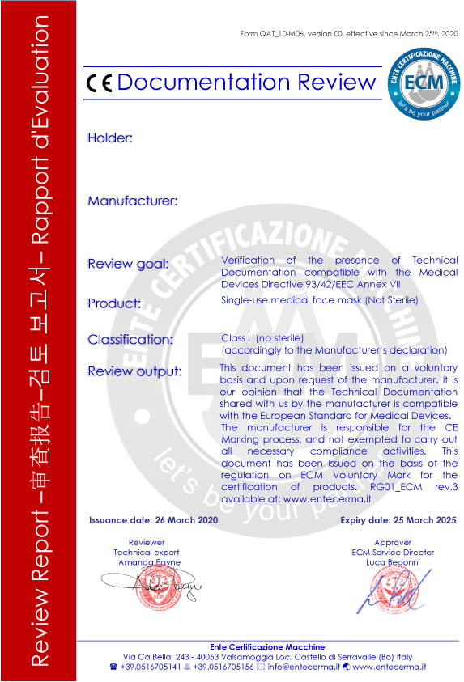

RV004XCAB DISPOSABLE 3-PLY SURGICAL MASK

